烛龙 V2 User Manual

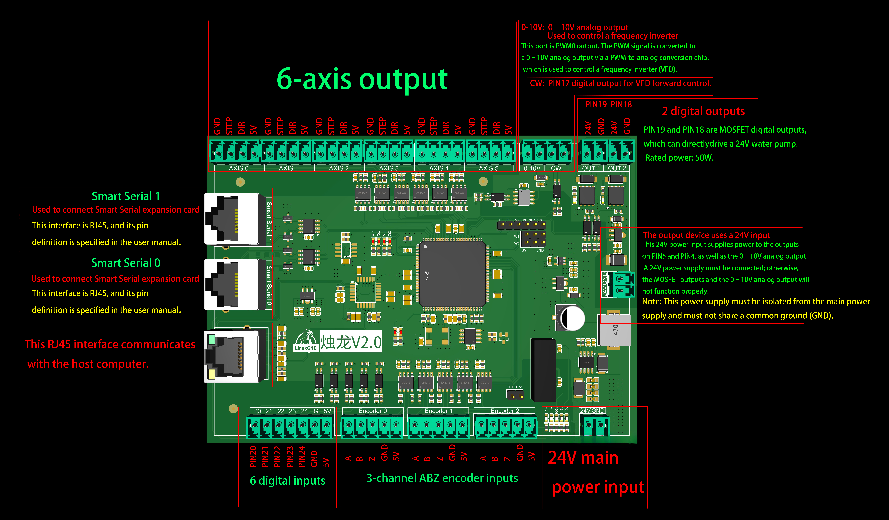
The 烛龙 V2 is a highly customizable 7I92 card that runs the open-source HostMot2 firmware. It is a low-cost, general-purpose FPGA programmable I/O card, primarily designed for motion control applications. The card connects to the host via 100Base-T Ethernet and can be configured directly using PNCconf.

1.The default IP address of the F7I92 V2 is 10.10.10.10.
2.Configured using PNCconf
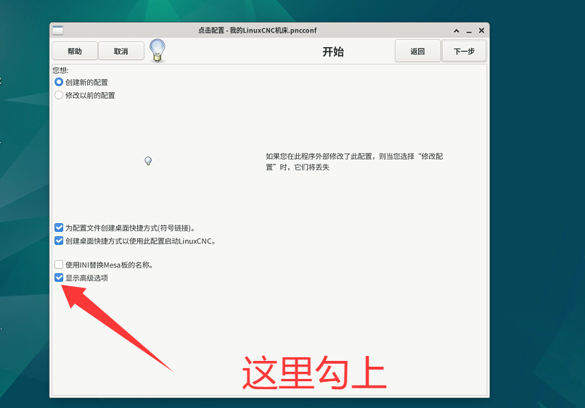
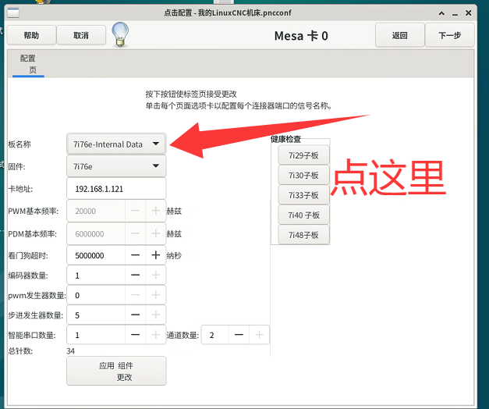

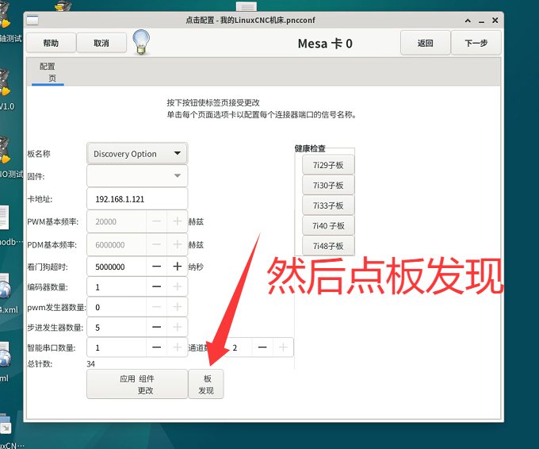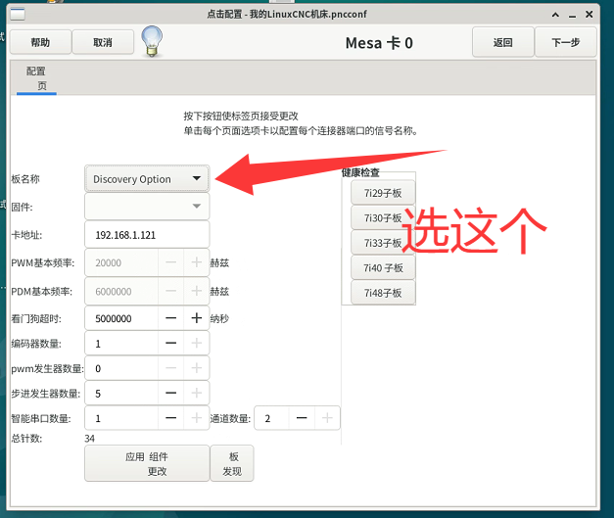
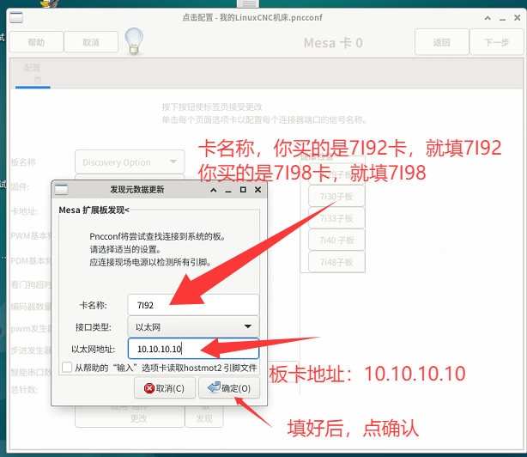
After clicking “OK,” the wizard tool can directly read the board’s I/O information. Subsequent configuration can continue by following the methods shown in the video.
Note: When configuring using the advanced options, ensure that the 烛龙 V2 is powered on and connected to the host first.

- Electrical Wiring Method
VFD:

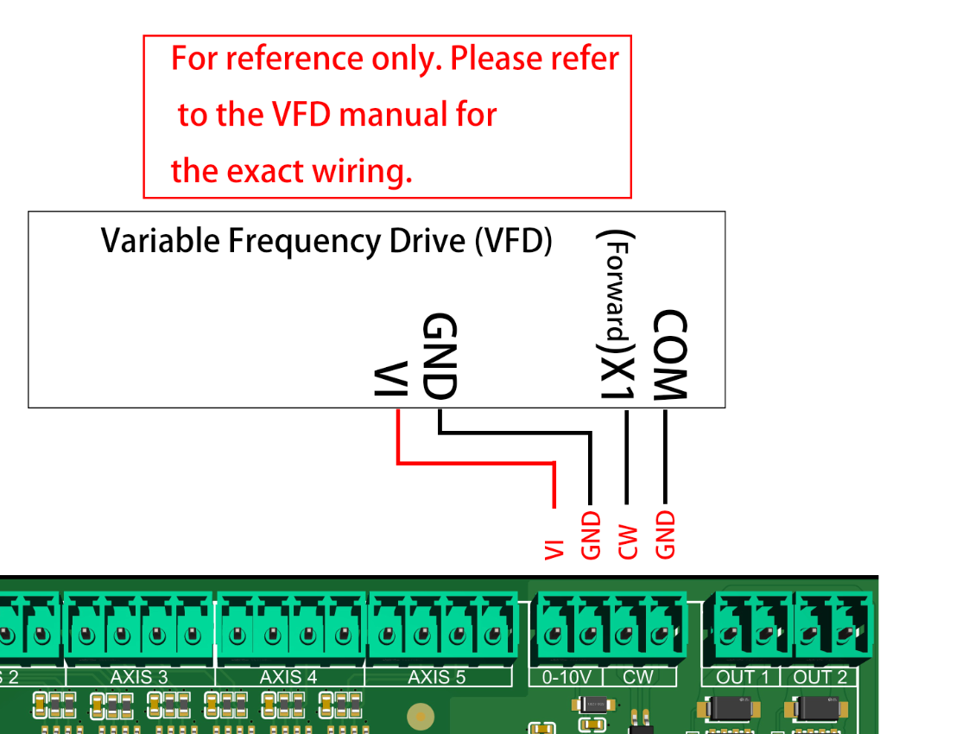

Motor Driver Wiring Method：
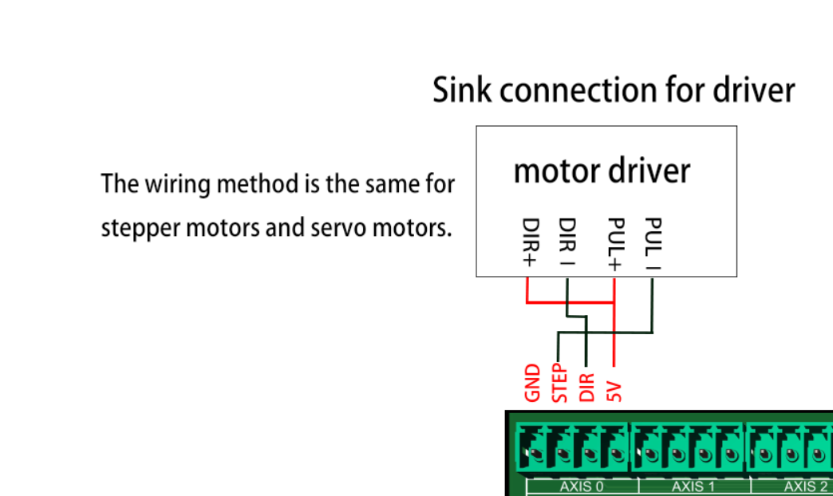

Note: Stepper motors or servo motors with 5V pulse inputs should be used!

Wiring Method for Input Devices：

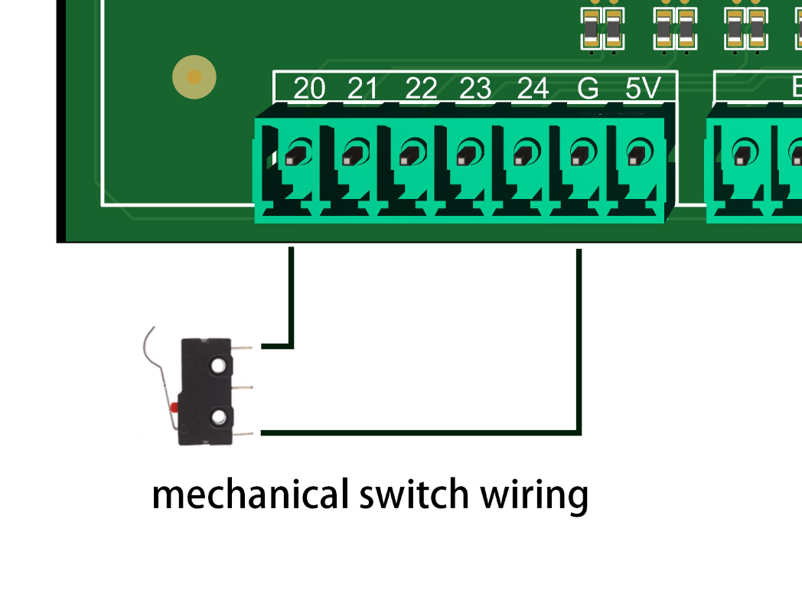

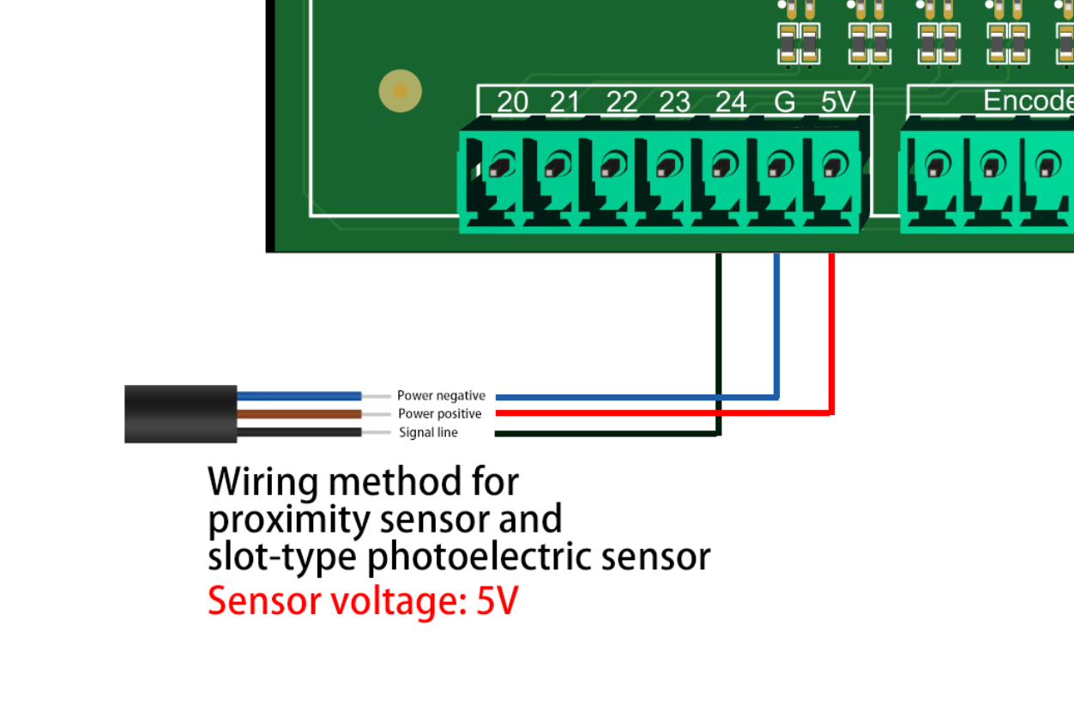

5.Advice on Host Optimization

To optimize jitter issues in LinuxCNC, consider the following aspects:
- Real-time Kernel: Using a real-time kernel can provide better real-time performance. Linux distributions such as Ubuntu offer dedicated real-time kernels, such as the PREEMPT-RT kernel or Xenomai kernel. Installing and switching to a real-time kernel may help reduce jitter.
- IRQ Affinity: Binding the interrupt requests (IRQs) of the CNC control card to specific CPU cores can reduce competition for interrupt handling and minimize jitter. Tools such as irqbalance or irqsettle can be used to set IRQ affinity.
- Disable Power-saving Features: Disable CPU power-saving features, such as Intel SpeedStep or AMD Cool’n’Quiet, to ensure the CPU runs at maximum performance during operation, which can reduce jitter.
- Optimize BIOS Settings: Some BIOS settings may affect real-time performance. Make sure to enable options related to real-time operation, such as disabling C-states or enabling HPET (High Precision Event Timer).
- Real-time Priority: Set the LinuxCNC process to real-time priority to ensure it has higher scheduling precedence. The chrt command can be used to set real-time priority.
- Hardware Optimization: Check and optimize hardware configurations, including power quality, cable connections, and grounding. Ensure stable power, proper grounding, and minimize electromagnetic interference.
Note: Before performing any optimizations, be sure to back up important data and configuration files, and proceed carefully to avoid unnecessary risks. It is also recommended to consult the official LinuxCNC documentation and user community for more detailed optimization advice and guidance.

- Reference materials for optimizing latency and jitter
Here are two web links you can refer to.
如何在LinuxCNC上减少抖动？Loriowar博客
8.There are two wiring options for the MPG (Manual Pulse Generator):
1.Connect the MPG to Encoder 0 on the PCB. In the PNCconf configuration tool, set the encoder count to 1. This frees up Encoder 1 and Encoder 2 as general-purpose input IOs, which can be used for the MPG’s axis selection and multiplier switches.
2.Purchase a matching Smart Serial MPG expansion board separately. This expansion board is equipped with 16 digital outputs, 8 digital inputs, and a 5-axis MPG interface.

9.Schematic Diagram of Smart Serial RJ45 Port
The schematic diagram of the Smart Serial RJ45 interface is provided. Users can also DIY their own Smart Serial expansion boards, and open-source projects for Smart Serial expansion boards are available on the LinuxCNC forum.
